Virtual Lesson Course Design and Teaching and Teaching Online

Background
There are 27 military instillations in Virginia including all four branches of the military: the Army, Navy, Air Force, and Coast Guard. Military recruiting efforts are highly concentrated in this area and many residents desire to join the military. Although many of these people are interested in joining the military and recruiters are eager to sign them up, many students face one obstacle in particular that keeps them from being able to join, the Armed Services Vocation Aptitude Battery test (ASVAB). The applicants’ score on this test will determine whether or not he/she qualifies for enlistment as well as what type of job and signing bonus the applicant is eligible for. There are companies that offer ASVAB prep courses online; however, they do not provide students with the support that they need to boost their scores. Recruiters are often in search of an online ASVAB prep course that will effectively raise the scores of their recruits.
There was a time when an education was not necessary in order to join the armed forces. However, the United States Armed Forces are now requiring soldiers to have high school educations and even college degrees. In many cases, the high school education is not enough. “Among young people who are recent high school graduates, more than one in five do not meet the minimum standard necessary to enlist in the U.S. Army” (Theokas, 2010, p. 1). These high school graduates that have goals of a military career need the help of an ASVAB preparatory course.
The public school systems in these Virginia areas take military recruitment almost as seriously as college recruitment. Recruiters often visit cafeterias, have private conferences with interested students and their counselors, and even have entire senior classes tested in auditorium-style seating. For the sake of this project, the college and career preparation counselors and teachers have developed an ASVAB prep course that spans over the course of 10 weeks. This course is delivered online so that students from high schools across the system can participate without having to be bussed physical locations after school.

Course Overview
The purpose of the online ASVAB prep course is to provide an accessible, interactive, preparatory course to K-12 students in a convenient setting and in a way that will not interfere with their school curriculum. There are four critical sections in the ASVAB: Arithmetic Reasoning, Word Knowledge, Paragraph Comprehension, and Mathematics Knowledge. There will be one module to cover each subject. According to Ally (2008), Cognitive psychology claims that learning involves the use of memory, motivation, and thinking, and that reflection plays an important part in learning” (p. 31). The ASVAB “prep” class will not only review the types of material that will be on the test, but also test taking skills and best practices. The course will encourage students to learn the subject matter by memorizing rules, principles, and laws and also teach them how to apply that information to different types of questions so that they are best prepared for whatever the test may bring. Students will explore each subject individually via interactive multi-media modules and will discuss different topics with the class. Students will take quizzes at the end of each week to test their knowledge on the subject matter and receive feedback from the instructor.

Measurable learning objectives
Upon completion of the course, students will be able to:
- Utilize test taking skills and best practices while taking practice and official ASVAB tests;
- Overcome weaknesses and challenges through discussions and interactions with classmates and instructors;
- Facilitate their own learning in study groups with student-teaching opportunities;
- Achieve at least a 40 on the official ASVAB, qualifying the student for entry into any branch of the military;
- Improve baseline test scores by at least 20%.
Presentation Modes
The content that will be covered in this course ranges from Mathematics, to spatial Recognition. Because of the wide array of subjects, the material must be presented in several different ways so that all students can benefit from its presentation. This form of repetition will not be overload; rather, it will be an opportunity for cognitive reinforcement. The materials will be taken from several text books and used for the development of learning modules, presented through Drupal, an open source content management system that allows users to create interactive learning modules. Students will be directed each week to the modules, which will be accessible via Blackboard. Student can log into Blackboard to access course content, participate in classroom activities, and contact instructors and peers. A link on Blackboard will take students to their coursework on Drupal, which will be divided up into modules and then weeks, so the students can easily navigate it. The hypermedia will take on a hierarchal structure such as the ones found in the text of Wang and Gearhart’s Designing and Developing Web-based Instruction (2006). Wang and Gearhart state that hierarchal structures start with general knowledge and move to a deeper level of content. The following is an example of the structure that will be used to deliver the course content:

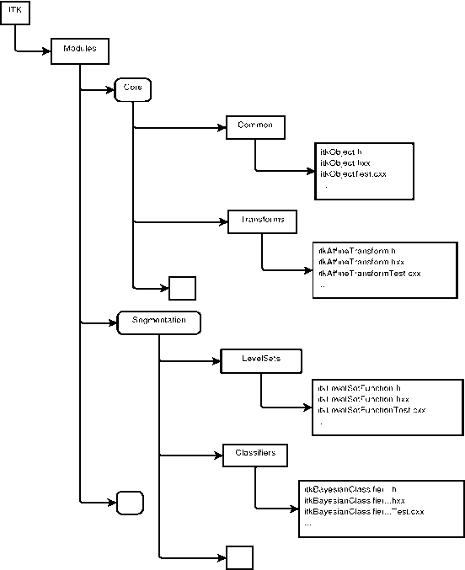

This image was taken from an article in the series, The Architecture of Open Source Applications (2011, Figure 9.3). Once students have completed their tasks in Drupal, including their assessments, they will return to Blackboard to communicate with their classmates and instructors. Each week will cover one sub-topic featured on the ASVAB test. They will also find on Blackboard access to eChapters of the textbooks, additional exercises that can be completed for practice, and interesting articles that will be used for class discussions. Lastly, students will be encouraged to “friend” each other on Facebook, Twitter, INstagram, and other social media sites so that they can sure they remain in contact with each other outside of the classroom. They will have study groups and partners and will hopefully want to share information with each other on their own time.

Course outline
- Module 1- Basic Training
  - “Pre-Course: Warming up”
    - Learning Objectives
      - Students will get acclimated to the Learning Management System, Blackboard, as well as other resources and to learn to navigate throughout the course.
      - Students will take the practice ASVAB test and submit their baseline scores to the instructor.
    - Course resources-
      - eChapters will be provided to students as reference from McGraw Hill’s ASVAB
      - Learning Modules presented through Drupal
    - Individual activities
      - Take practice test and submit scores
      - Introductions in the conference area
      - Participation in the conference discussion
    - Group activities
      - Placement in study groups based off of test scores (to occur after receipt of test scores).
      - Assignment of a class “buddy” who has similar weaknesses (to occur after receipt of test scores)
    - Assessment- Pre-knowledge ASVAB test
    - Discussion topics-
      - Personal Stories
      - Introductions
      - “Why Can’t I get the Score I Want?”
    - Due Dates- all assignments (assessment and participation) will be due on Sundays by midnight, unless otherwise stated. This will allow the instructor to provide feedback by the following Monday nights.
  - “Week 1- Eyes on the Prize”
    - Learning Objectives
      - Students will understand the format of the ASVAB test
      - Students will be familiar with the scoring system
      - Students will create their own personal goals for ASVAB achievement.
- Module 2- The Verbal Hurdle
  - “Week 3- Word Knowledge”
    - Learning Objectives
      - Students will be familiar with common Latin root words, prefixes, and suffixes
      - Students will be able to define common vocabulary words used in testing scenarios
  - “Week 4- Paragraph Comprehension”
    - Learning Objectives
      - Students will practice reading skills
      - Students will be able to identify main ideas, sentence meaning, and paragraph structure
- Module 3- The Math Crawl
  - “Week 5- Arithmetic Reasoning”
    - Learning Objectives
      - Students will review and practice basic arithmetic in various forms
  - “Week 6- Math Knowledge”
    - Learning Objectives
      - Students will be able to solve word problems and algebraic expressions
- Module 4- The Science and Technical Ladder
  - “Week 7- Generally Speaking”
    - Learning Objectives
      - Students will review and recall basic scientific theories and phenomena
  - “Week 8- The Technological Sprint
    - Learning Objectives
      - Students will review concepts and basics pertaining to automotive and technological knowledge
      - Students will be able to perform spatial recognition tasks and put objects together in their minds
- “Post-Course: The Finish Line”
  - In this post week students will take their last practice ASVAB of the course and reflect on their progress if so desired

Lesson Plan Example

Eyes on the Prize
Subject | Teacher | Grade | Date
ASVAB | Tatum | 12 | September 30, 2013
Overview
This lesson plan outlines the second week of the ASVAB prep course. This week is called “Eyes on the Prize” because it is built to introduce students to the ASVAB and break it down to simple concepts that are easy for students to understand and master. The objective is to create attainable and realistic goals and to build social relationships and a sense of community amongst the students.
 | Teacher Guide | Student Guide
Objectives | - Students will understand the format of the ASVAB test  - Students will be familiar with the scoring system  The purpose is to give students a general understanding of the ASVAB so they can understand how we will tackle studying for it. | - Students will understand the format of the ASVAB test  - Students will be familiar with the scoring system
Information | eChapters will be provided to students as reference from McGraw Hill’s ASVAB  Links will also be posted to the discussions to help stir up conversation | Students will not only use McGraw Hill, but also the following articles:  Theokas, C., & Education, T. (2010). Shut Out of the Military: Today's High School Education Doesn't Mean You're Ready for Today's Army. K-12 Policy.Education Trust, (2010, December 22).  Villarreal, P. (2009, November 12). I don't want you: 70% of young unfit for military. Arizona Daily Star (Tucson, AZ).
Activity | - Assessment of Pre-Knowledge ASVAB Test  - Assignment of a class “buddy” who has similar weaknesses | Discussion Topics:  (Monday) Introductions- Students will be enrolled from different schools. Who are you?  (Wednesday) Personal Stories- why are we here  (Thursday) “Why Can’t I get the Score I Want?”
Verification | This week will be used to measure the level of commitment of each student. During the activity and verification process, it will be important to note the students’ dedication to their own personal growth | Students will write a reflective summary on why they are enrolled in the course, which section they think they will be the best in and which will be the worst, and lastly, their goals for the ASVAB
Summary | Once this week is complete, the teacher should initiate the conferences with the students to discuss their personal courses of action | At the end of this week, each student should start to feel a sense of community as if everyone has the same goal and is here to learn and that the instructor has his/her best interest at heart

References

Ally, M. (2008). Foundations of educational theory for online learning. In T. Anderson (Ed.), The Theory and practice of online learning (2nd Ed.) pp. 15- 49. Athabasca, CA:Athabasca University Press. Retrieved from http://www.aupress.ca/books/120146/ebook/99Z_Anderson_2008- Theory_and_Practice_of_Online_Learning.pdf

Reigeluth, C., Merrill, M. M., & Bunderson, C. C. (1978). The structure of subject matter content and its instructional design implications. Instructional Science, 7(2), 107. doi:10.1007/BF00121929
Theokas, C., & Education, T. (2010). Shut Out of the Military: Today's High School Education Doesn't Mean You're Ready for Today's Army. K-12 Policy.Education Trust, (2010, December 22).

Villarreal, P. (2009, November 12). I don't want you: 70% of young unfit for military. Arizona Daily Star (Tucson, AZ).

Wang, H. & Gerhart, D.L. (2006). Designing and Developing Web-based Instruction. Upper Saddle River, N.J.: Pearson Education.

