Classifying Virtual Schools
As technology advances, our government and citizens are all trying to find ways to keep up. New opportunities arise every day, just as people are getting used to the changes most recently made. This is happening in the education system as well. Distance education is growing faster than ever, with thousands of schools now offering online courses, and our public school system is trying to hop on the bandwagon. The emergence of virtual schools in the public system has been one of the most profound uses of the opportunities that technology has afforded. According to Reid et al. (2009), “Virtual high schools in academic year 2000–2001 offered more than 200 high school courses to nearly 4000 students in 350 schools in 30 states in the United States” (p. 282).
Virtual schools are simply defined as online institutions offering classes that may not otherwise be available in the classroom. However, classifying virtual schools is less simple. There are many types of virtual schools available to students including, but not limited to consortium and regionally based schools, private schools, multi and single district programs, and charter schools (Barbour & Reeves, 2009, p. 405). According to Barbour and Reeves (2009), “a virtual school is an entity approved by a state or governing body that offers courses through distance delivery” (p. 402). These programs can be classified in different ways, but they can all be categorized by certain dimensions: comprehensiveness, reach, type, location, delivery, operational control, type of instruction, grade level, teacher-student interaction, and student-student interaction (Matthew Wicks and Associates, 2010). Using these dimensions, along with other criteria, virtual schools can be placed into categories that will allow school systems to decide what fits them best. This paper will attempt to outline those types of virtual schools and discuss who would benefit most from them.
Scholars classify virtual schools using many different criteria. Clark (2001), in his classification of schools, focused on the organization that would be administering the school while Watson et al. (2004) focused on the geographic reach of the school. Others may classify virtual schools by who would be participating in that particular program. While some believe that only certain types of students can benefit from virtual schooling, the International Association for K-12 Online Learning (iNACOL) believes that “all students [should] have the opportunity to choose an online learning course or program that meets their needs as a part of their K-12 education” (p. 48). While it would be ideal for every student to be able to benefit from online learning and virtual schooling, not every student is the same. Within the student population, there are several different types of students; those with individual learning plans (IEPs), need for remedial coursework, require or want classes not available to them at their current school (IB, AP, technical courses), those in need of drop-out prevention, and those that need to catch up in class (credit recovery). Considering these different situations, it is necessary to determine which student would benefit from which type of school. Berge and Clark (2005) outline four benefits of virtual schools: expanding educational access, providing high quality learning opportunities, improving student outcomes and skills, and allowing educational choice (Barbour& Reeves, 2009).
Each state, school district, private school, and for profit educational organization will define their virtual learning department differently. The state of Florida provides free online learning to all residents, giving priorities to students needing additional classes to meet their academic goals. Students participating in the Florida Virtual Schools (FLVS) program includes those that are home schooled, attend low performing schools, attend rural, inner-city, or other schools that may have limited courses offerings, and those that are seek to obtain a high school diploma at least one semester early (Florida Public Schools). The Virginia Department of Education also has a similar program, Virtual Virginia, which offers Advanced Placement (AP) courses, honors courses, electives, and world languages to students that do not have access to such classes. However, such programs only cater to academically advanced students, not those needing help. While Virtual Virginia exists at the state level, individual districts contract private virtual schools and courses that align with state and district requirements and curricula. NovaNET, in particular, is commonly used for dropout prevention, credit recovery, alternative instruction, summer school, special education, and homebound learning (NovaNET Courseware Overview).
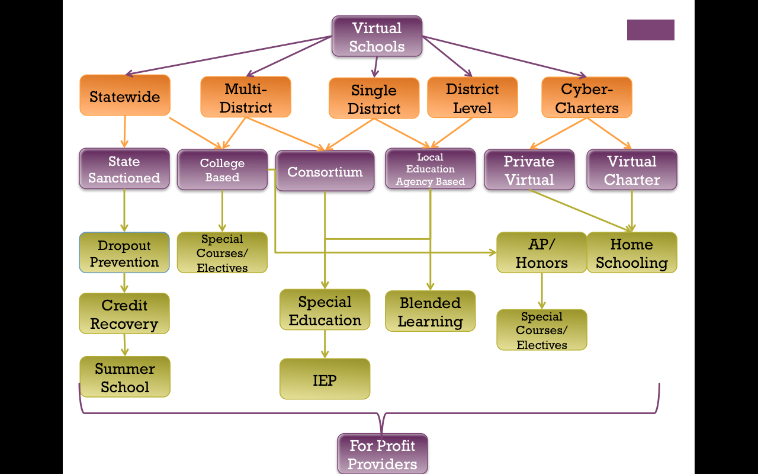
Using this information, it is possible to create a classification system that uses all of these criteria. The above image illustrates how each geographic region can employ an organization to achieve a certain goal. Certain tasks, such as preventing high school dropouts, would be considered a state initiative, as shown in the diagram. While each entity may develop its own initiatives, typically organizations will associate with specific government levels and educational departments. For-profit providers are able to create partnerships with any level and typically have the capacity to cater to any type of student. The logic behind this organization is that school systems, districts, and departments of education should offer a limited amount of online educational resources. Government agencies should focus on educating students that are falling behind in their requirements or proper level of education. Private institutions can offer additional courses and resources to students who want to get ahead in their education. As some schools are not able to offer what are normally standard courses, due to lack of funding or otherwise, a consortium of schools or districts can partner in offering those courses.
Classifying virtual schools is important because, like with the implementation of most distance education programs, developing a sound structure is the foundation of a successful program. According the Reid, “Successful creation of a virtual school is dependent upon more than developing or acquiring quality online courses, preparing competent online teachers and securing adequate funding (Reid, et al., 2009, p. 293). What is most important is the structural and organizational development that surrounds the course. In the public school system, there are many legal and financial limitations to implementing new programs. In addition to these limitations, there are also state and federal educational goals and requirements that must be met by each school and district. Keeping that in mind, each entity must choose the appropriate organization to provide online learning to its students. Unfortunately, most districts lack the manpower and resources to be able to operate a distance-learning department in-house. In order for virtual schools to be properly implemented into the school systems, administrators must understand the needs of their students in order to determine what type of organization—for-profit, college based, or otherwise—to choose.
Therefore, when classifying virtual schools, one should take into account not only the geographic reach of the school, but also more importantly, what type of student will participate in the school. The students’ needs determine the organization that provides the education for that particular student. Students with like needs and requirements should be educated by the organization that can best meet that need. School systems and districts should work within the scope of their means and prioritize according to the needs of the specific students. With models being identified, and structure being set, students will then know where to look in order to achieve their goals and school systems will be able to offer the proper resources.

References
Barbour, M., Reeves, T., (2009). The reality of virtual schools: A review of the literature. Computers and Education, 52, 402-416.
Florida Public Virtual Schools. Florida Department of Education. Retrieved June 17th, 2013, from https://www.fldoe.org/schools/virtual-schools/faqs.asp
Matthew Wicks and Associates. (2010). National Primer on K-12 Online Learning. Washington DC: iNacol. http://www.inacol.org/cms/wp-content/uploads/2012/11/iNCL_NationalPrimerv22010- web1.pdf
Reid, K. M., Aqui, Y., & Putney, L. G. (2009). Evaluation of an evolving virtual high school. Educational Media International, 46(4), 281-294. doi:10.1080/09523980903387522
NovaNET Courseware. NovaNET Courseware Overview. Retrieved June 17th, 2013, from http://www.nn.com/about

